* First model:
  + Generate constant FOI from incidence data stratified by age
  + Then use the FOI to generate cases, Incidence rate, mortality, disability, DALY.
  + Details methods:
    - When generate FOI, pop of each country was used => too large => use rho: reporting rate
    - Different scenarios were different by population and defined as:
      * Campaign: = > sequence year defined by the result of last year shift 1 to below.
      * Routine: => sequence year was defined by the product of last year shift 1 to the left
    - Generate annual cases by: ( is reporting rate)
    - Reporting uniform(1/500, 1/250)
    - Mortality:
    - Disability:
    - DALY:
      * DALY calculate based on these 2 tables:
        + 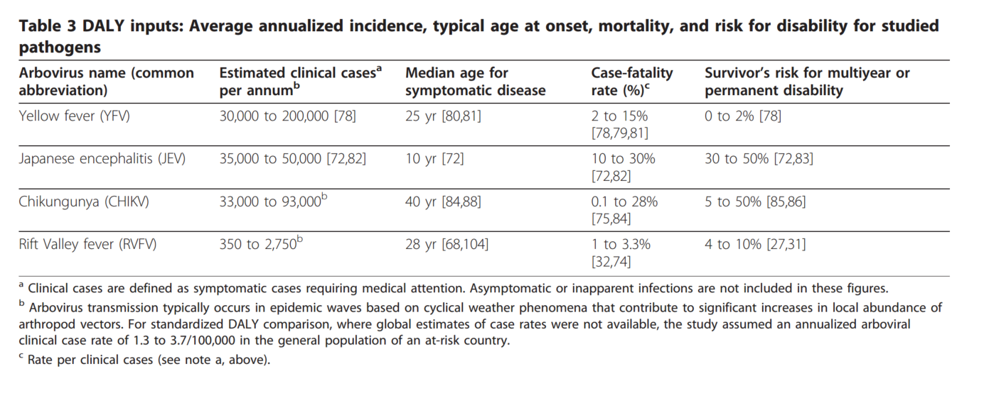
        + 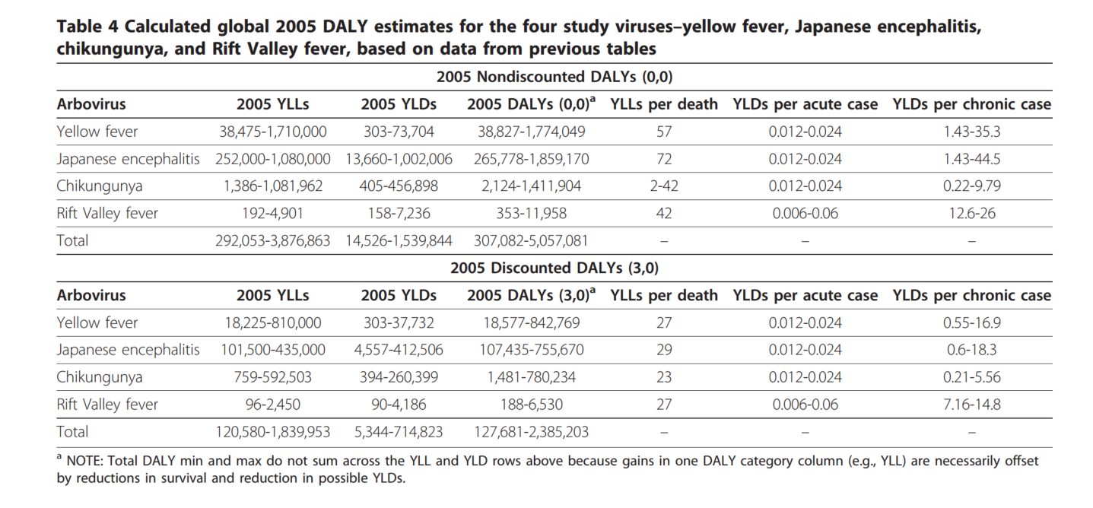
  + Results: our estimation is lower compared to Campbell 2011 => may due to not good fit model (in Cambodia) and wrong risk population (in Indonesia).
* Montagu data refine and interpret:
  + Code in :JEV_Montagu_data
  + Use the code to generate the dataset of pop based on different scenarios:
    - No vaccination
    - Routine
    - Campaign (+ Routine)
  + An example output:
    - Naïve Demo data

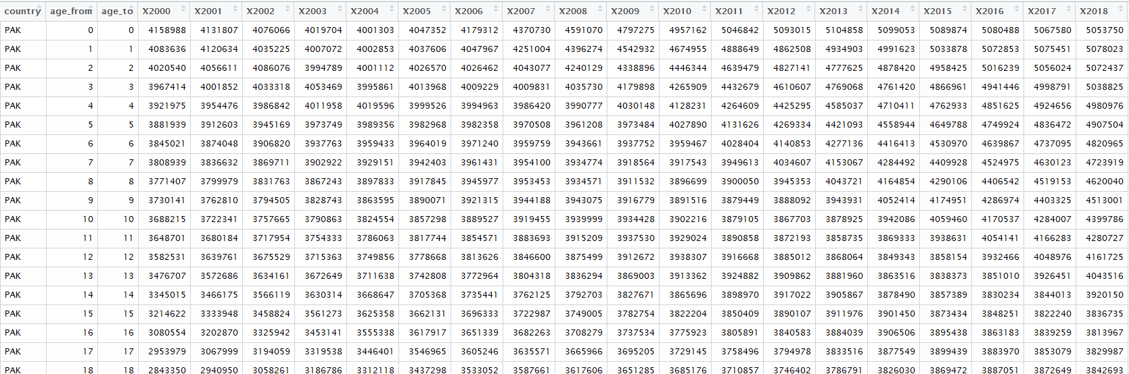

* Cam data:
* 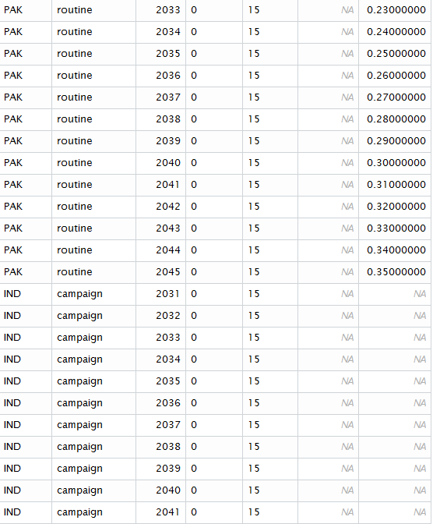
* Rou data:
* 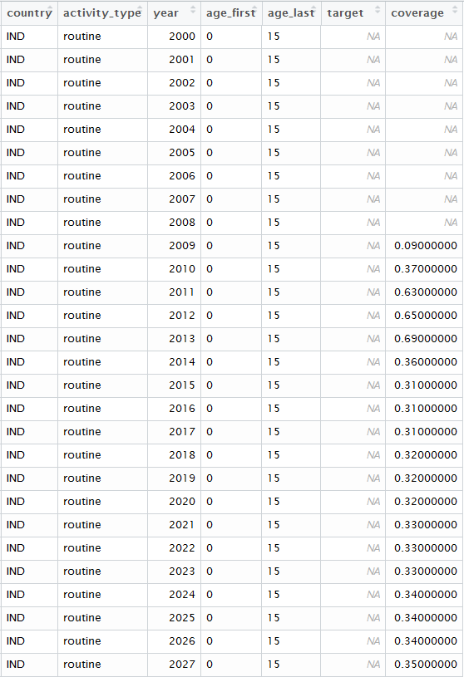
  + Queries:
    - Campaign scenario: the combination of both cam and rou? Also inspecting the target population
    - Routine scenario: the coverages are for all age group? Should it be a routine vaccination in age group 1 ?
  + Current set up for the demographic data:
    - Routine scenario: vaccinating the age group from 0 to 1 year old. The model also takes account the aging vaccinated ppl each year after.
    - Campaign scenario: vaccinating the age group from 0 to 15 year old. The model also takes account the aging vaccinated ppl each year after. Also + the routine scenario. If the years of campaign vaccination are close enough, the sequenced programs will vaccinate the unvaccinated ppl (the leftover) from the previous programs => best estimation scenario.
* Incidence data to generate FOI: (code in JE_cases_model-Montagu_data_and_template)
  + Based on Campbell 2011:
    - India:
      * Lowest incidence:
        + North-west: Haryana, Punjab
        + => group B => get info from group A: Japan
      * Medium incidence:
        + South: Andhra Pradesh, Goa, Kerala, Karnataka, Maharashtra, Pondicherry, Tamil Nadu
        + => group H => data from Malaysia. But data from Mal is unavailable => use this data: India_Japanese encephalitis in Tamil Nadu (2007-2009).
      * High incidence:
        + North-central and north-eastern: Assam, Bangla [West Bengal], Bihar, Manipur, Uttar Pradesh. => group F => data from Nepal (non-west Terai)
    - Parkistan: => group B => get info from group A: Japan
    - Result:

|  |  |  |  |  |  |
| --- | --- | --- | --- | --- | --- |
| Country | Sub group | Cases | Incidence rate/previous est | lambda | rho |
| India | Lowest | 0.146(0.084-0.224) | 0.013(0.0075-0.02)/0.001 (<15) | 0.0002572152 (All age) | 0.0746895895  (All age) |
|  | M-H | 45(27-60) | 0.637(0.124-1.558)/4.7 | 0.284186668 (0-18) | 0.001750758  (0-18) |
|  | High | 135(75-225) | 2.16(1.19-3.55)/5.1 | 0.08384097 (All age) | 1.782843e-05 (All age) |
| Pakistan |  | 0.117(0.069-0.179) | 0.013(0.0075-0.02)/0.001 (<15) | 0.0002311688  (All age) | 0.0845301069  (All age) | |

* + - Result with reporting rate sample from uniform(1/500,1/250):

|  |  |  |  |  |  |  |  |  |  |  |
| --- | --- | --- | --- | --- | --- | --- | --- | --- | --- | --- |
| Country | | Sub group | | Cases | Incidence rate/previous est | | | lambda | rho | |
| India | | Lowest | | 11(0.00046885575-90) | 1(5e-05-9.77)/0.001 (<15) | | | 0.0002572152 (All age) | 0.0746895895  (All age) | |
|  | M-H | | 75000(12000-140000) | | | 1083 (166-2018)/4.7 | 0.284186668 (0-18) | | | 0.00001750758  (0-18) |
|  | | High | | 23000(13000-36000) | 363(208-565)/5.1 | | | 0.08384097 (All age) | 1.782843e-05 (All age) | |
|  | |  | |  |  | | |  |  | |

* + - Result with reporting rate sample from uniform(1/500,1/250) and also account for the reduce of susceptible people due to infection, FOI in medium incidence = FOI in high incidence:

|  |  |  |  |  |  |
| --- | --- | --- | --- | --- | --- |
| Country | Sub group | Cases | Incidence rate/previous est | lambda | rho |
| India | Lowest | 9(5e-4 to 90) | 0.88(5e-05-8.7)/0.001 (<15) | 0.0002572152 (All age) | 0.0746895895  (All age) |
|  | M-H | 15000(10000-22000) | 212 (135-300)/4.7 | 0.08384097 (All age) | 1.78e-05 (All age) |
|  | High | 14000(9000-20000) | 212 (135-300)/5.1 | 0.08384097 (All age) | 1.782843e-05 (All age) |
| Pakistan |  | 10(4e-04 to 90) | 1.076 (5e-05-10.7)/0.001 (<15) | 0.0002311688  (All age) | 0.0845301069  (All age) |

Plot of cases in lowest incidence region in India: due to not many infected cases, the immunity of population doesn’t affect the dynamic much.  
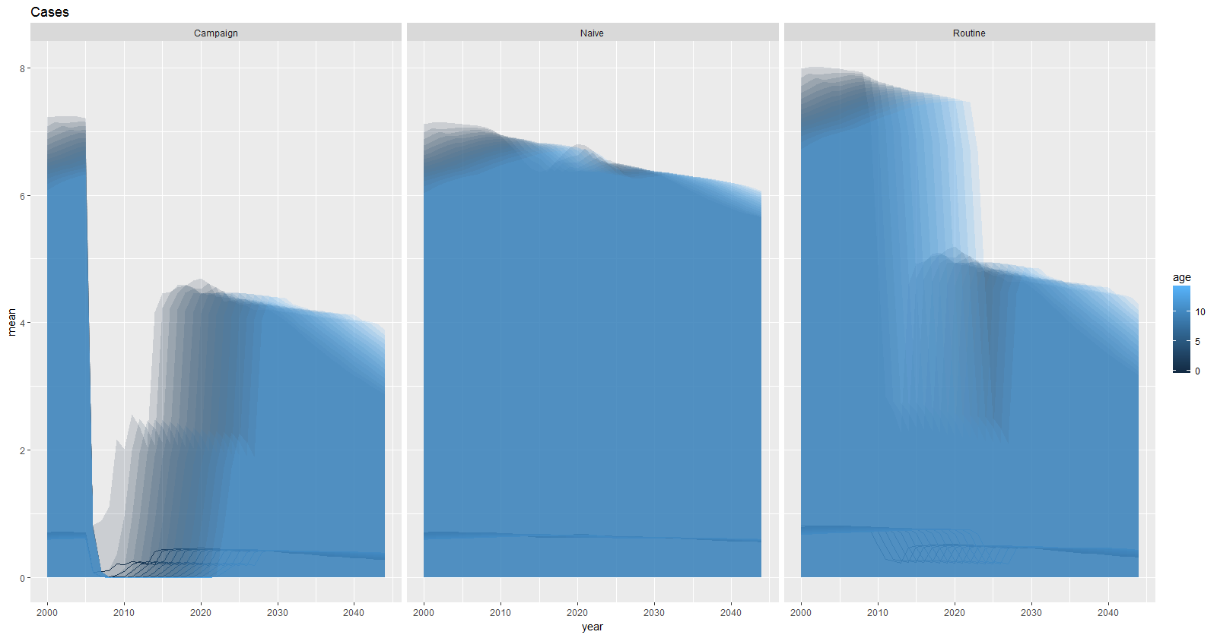

Plot of cases in high incidence region in India: the immunity of population does affect the dynamic significantly.

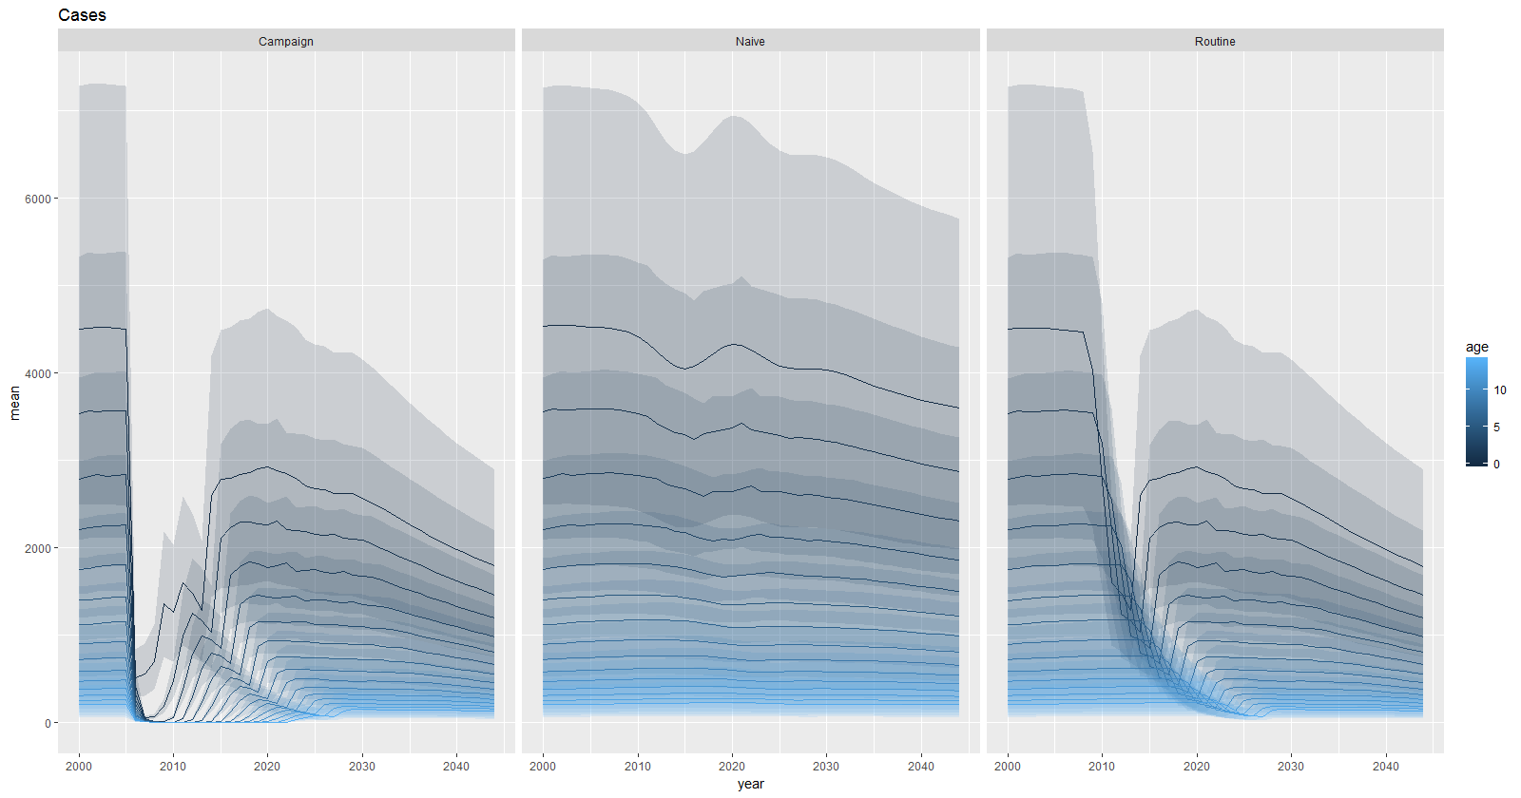

I rerun the m-high incidence model with Tamil Nadu data (which I originally did in previous estimation) and it gives me the weird result like this:

mean se_mean sd X2.5. X25. X50.

rho 0.002071428 0.001134165 0.03396173 7.393984e-07 1.258877e-06 1.621304e-06

X75. X97.5.

2.064704e-06 3.699126e-06

n_eff Rhat

rho 896.658 1.006403

rho may change a little bit compare to 0.00175 as previous estimation because of low n_eff, but the credible interval is very weird.

Plots generated from templates: columns are the different run id, different grades of blue line are numbers of cases in different age groups of the stochastic model, grey lines are numbers of cases in deterministic model.

No vaccination scenario:

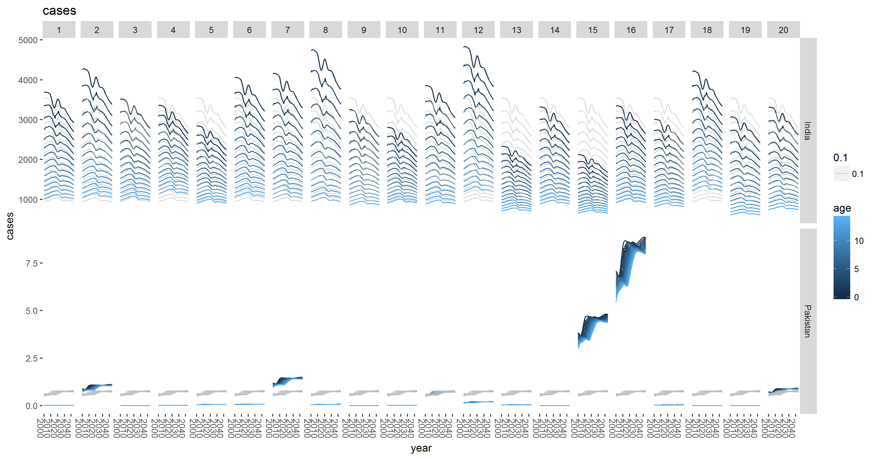

Campaign vaccination scenario:

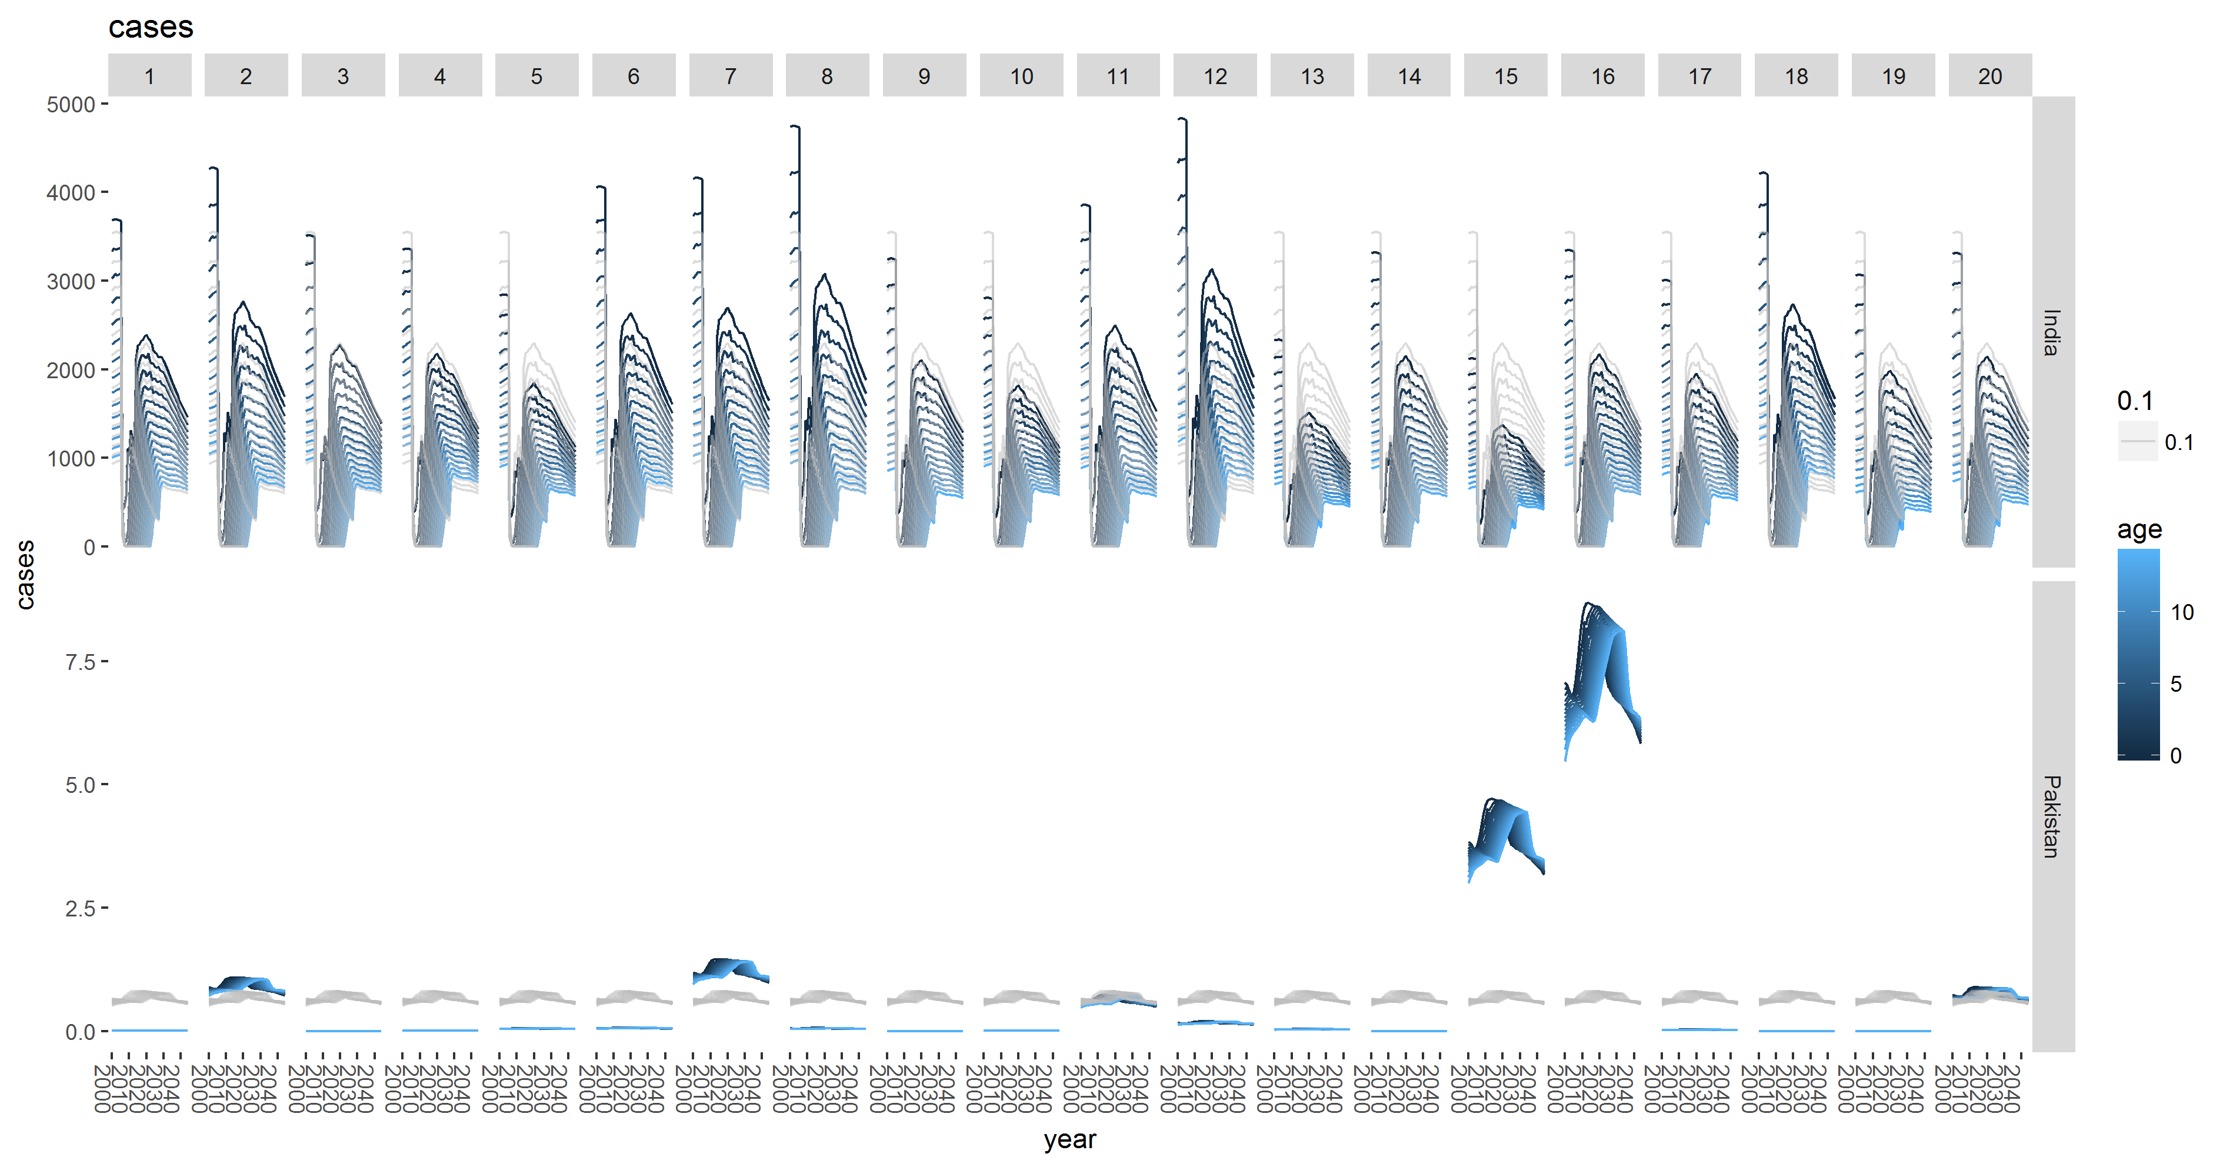

Routine vaccination scenario:

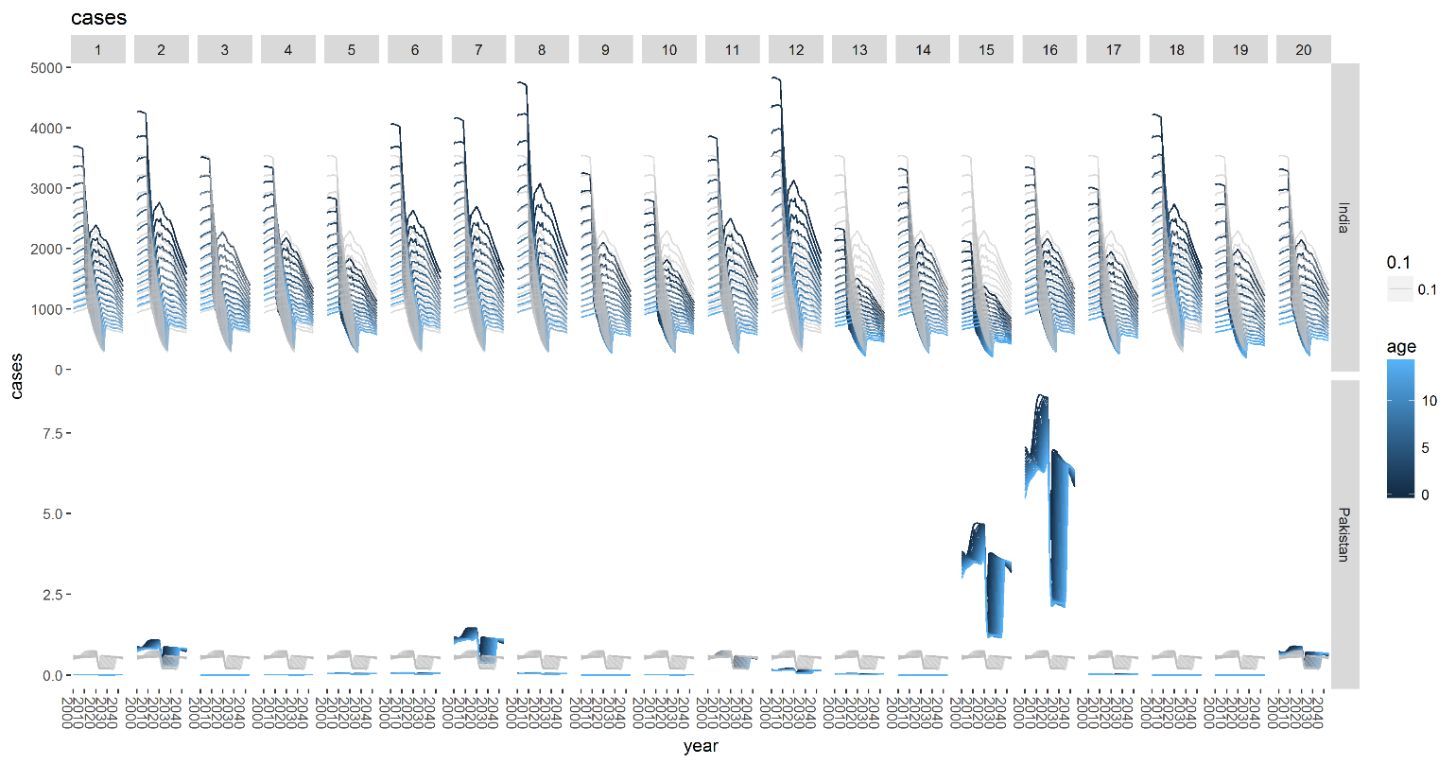

Conclusion: there are more variance in the results of Pakistan compared to India.

* Current model description Oct 12th 2017: constant FOI from age-stratified incidence data
  + Work flow:
    - Finding age-stratified incidence data from literature search.
    - Also need the age-stratified population data based on the age group and location of incidence data (may include the effect of vaccination or not).
    - Using basic catalytic model:
      * The likelihood of proportion of cases in a specific age group
        + (age low and age up are the lower and upper boundary of each age group in the incidence data, is the constant FOI)
      * The likelihood of expected cases in a specific age group
        + ( is number of susceptible people in that age group, is reporting rate, comprised of asymptomatic rate and reporting rate from health system – which may varied between studies)
      * The log multinomial likelihood function for all age group:
        + ( total cases of all age group)
      * The multinomial likelihood function include Poisson distribution of total cases across all age group:
        + Fit this log-likelihood function in Bayesian framework, with 2 parameters:
      * The susceptible population for each vaccination scenario is different:
        + No vaccination: the demographic in a country from 2000 to 2045.
        + Routine scenario: vaccinated the 1st age group and also counting the aging effect (next year, the vaccinated age group will move down 1 row = add 1 age, the newborn group will continue to be vaccinated).
        + Campaign scenario: The whole population remained susceptible after the Routine Vaccination will undergo Campaign vaccinations, which vaccinated 15 age groups of the given year, based on the coverage proportions. Also, counting the aging effect. If there are multiples Campaign vaccinations, the after one will vaccinate the leftover of the previous vaccinated population.
    - Output from the model:
      * Estimate cases, deaths, daly:
        + Generate annual cases by: ( is asymtompmatic rate, a is age group from 1 to 15 –which account for the reduced susceptible population when children get older, population is the susceptible population under different scenarios)
        + Asymptomatic rate uniform(1/500, 1/250)
        + Mortality:
        + Disability:
        + DALY:
        + DALY calculate based on these 2 tables:





* + - * Current data used:
        + Population data:

Montagu: India, Pakistan => used for generating quantity like cases, deaths, dalys

IDB data: Japan, Cambodia, Indonesia => used for population size in the model.

Subnational data: province population at one time point derived from various sources (describe in JE_Pop_all_age_col.R) => used to get the population size by age group (Pop_all_age column) in the model.

* + - * + Incidence data: (papers stored in “doc_papers that contain data”)

India:

Lowest: Japan_Japanese encephalitis - surveillance and elimination effort in Japan from 1982 to 2004.

Medium high: Nepal_Laboratory-based Japanese encephalitis surveillance in Nepal and the implications for a national immunization strategy. (non-Terai)

High: Nepal_Laboratory-based Japanese encephalitis surveillance in Nepal and the implications for a national immunization strategy. (non-Terai)

Pakistan: Japan_Japanese encephalitis - surveillance and elimination effort in Japan from 1982 to 2004.

Cambodia: Cambodia_Epidemiology and burden of disease from Japanese encephalitis in Cambodia - results from two years of sentinel surveillance.

Indonesia: Indonesia_Confirmation of Japanese encephalitis as an endemic human disease through sentinel surveillance in Indonesia.

* Current model description Dec 5th 2017: constant FOI from age-stratified incidence data => result of 14 countries
  + Current data used:
    - Population data:
      * Montagu: 14 countries; subnational data from Campbell 2011 => used for generating quantity like cases, deaths, dalys.
      * Subnational data: province population at one time point derived from various sources (describe in JE_Pop_all_age_col.R) => used to get the population size by age group (Pop_all_age column) in the model.
    - Incidence data: (papers stored in “doc_papers that contain data”)
      * India:
        + Lowest: Japan_Japanese encephalitis - surveillance and elimination effort in Japan from 1982 to 2004.
        + Medium high: Japanese encephalitis virus remains an important cause of encephalitis in Thailand (in the same group H by Campbell 2001)
        + High: JAPANESE ENCEPHALITIS IN ASSAM, NORTHEAST INDIA 2000-2002
      * Pakistan: Japan_Japanese encephalitis - surveillance and elimination effort in Japan from 1982 to 2004.
      * Cambodia: Aetiology of acute meningoencephalitis in Cambodian children- 2010-2013
      * Indonesia:
        + Low: Japanese encephalitis virus remains an important cause of encephalitis in Thailand (medium class by Campbell 2001)
        + High: Indonesia_Confirmation of Japanese encephalitis as an endemic human disease through sentinel surveillance in Indonesia.
      * Laos: A Prospective Assessment of the Accuracy of Commercial IgM ELISAs in Diagnosis of Japanese Encephalitis Virus Infections in Patients with Suspected Central Nervous System Infections in Laos.
      * Vietnam: A Prospective Assessment of the Accuracy of Commercial IgM ELISAs in Diagnosis of Japanese Encephalitis Virus Infections in Patients with Suspected Central Nervous System Infections in Laos. (due to geographic)
      * Bangladesh: Hospital-Based Surveillance for Japanese Encephalitis at Four Sites in Bangladesh, 2003–2005
      * Nepal: Nepal_Laboratory-based Japanese encephalitis surveillance in Nepal and the implications for a national immunization strategy. (combined data from western and non-western Terai)
      * Butan: Nepal_Laboratory-based Japanese encephalitis surveillance in Nepal and the implications for a national immunization strategy. (combined data from western and non-western Terai) (due to geographic)
      * North Korea: Japanese encephalitis virus remains an important cause of encephalitis in Thailand (medium class by Campbell 2001)
      * Burma: Japanese encephalitis virus remains an important cause of encephalitis in Thailand (due to geographic)
      * PNG: Japanese encephalitis virus remains an important cause of encephalitis in Thailand (the same as low Indonesia due to geographic)
      * Srilanka: Japanese encephalitis virus remains an important cause of encephalitis in Thailand (due to geographic)
      * Timor-leste: Indonesia_Confirmation of Japanese encephalitis as an endemic human disease through sentinel surveillance in Indonesia. (due to geographic)
* Current model description Jan 5th 2017: constant FOI from age-stratified incidence data => result of 16 countries
  + Change the calculation of DALYs: also account for the age table, the acute and chronic weight (now only use Acute encephalitis and Severe motor plus cognitive impairments due to encephalitis) got from VIMC.
    - The YDL_chronic is calculated to be the same time as the acute, not over the remainder of the time the person is experiencing this symptom (sometimes for the rest of the life)
  + There are 2 ways of generating central estimations:
    - Single model run: cal FOI => get the mean of FOI distribution => calculate central estimations based on the mean. (output in “tes3_singlemodel_...”, the code is JEV_cases_model - test 3 - 16 countries - a single model run.R)
    - Multiple model run: cal FOI => get the FOI distribution => average central estimations from the sample of FOI distribution. (output in “test3_...”, the code is JEV_cases_model - test 3 - 16 countries.R)
  + Change the way of calculating FOI:
    - now the population size by age group in the model is the sum of all people in that age group over the time the study conducted => Pop_all_age_year_sum columns are generated from JE_Pop_all_age_year_sum_col.R code
    - The vaccination information is also included in the Pop_all_age_year_sum columns.
    - All estimated FOI can be gotten from JEV_cases_model_based_on_Hannah_code.R
  + Current data used:
    - Population data:
      * Montagu: 16 countries; subnational data from Campbell 2011 => used for generating quantity like cases, deaths, dalys.
      * Subnational data: province population at one time point derived from various sources (describe in JE_Pop_all_age_col.R and JE_Pop_all_age_year_sum_col.R) => used to get the population size by age group (Pop_all_age and Pop_all_age _year_sum columns) in the model.
    - Incidence data: (papers stored in “doc_papers that contain data”)
      * Philippines: Epidemiology of Japanese Encephalitis in the Philippines: A Systematic Review.
      * India:
        + Lowest: sample from the distribution: lognormal(mean = log(0.01), sd = 1)
        + Medium high: Japanese encephalitis virus remains an important cause of encephalitis in Thailand (in the same group H by Campbell 2001)
        + High: JAPANESE ENCEPHALITIS IN ASSAM, NORTHEAST INDIA 2000-2002
      * Pakistan: sample from the distribution: lognormal(mean = log(0.01), sd = 1)
    - Others countries are the same as the previous version